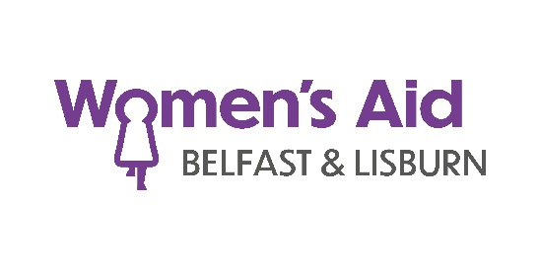

Our Vision
Our vision for the 21st century is the elimination of domestic abuse.

Our Mission
Women’s Aid exists to challenge attitudes, structures and systems which perpetuate domestic abuse. We seek through our work to enable women, children and young people to live free from violence and abuse. Our mission is to:
- To provide safety and support for women and children who experience domestic abuse.
- To work for and with women and children to ensure their voices are heard and their needs are met.
- To challenge attitudes and beliefs that perpetuate domestic abuse as a form of violence against women.

Our Ethos
Our strong ethos has been built upon our rich heritage of campaigning to end domestic abuse, which began in the 1970s and continues to be based upon our working premise of: for women, with women, by women which is inherent in our service development and delivery.

Our Core Aims
- Engage with women, children and young people, to give them a voice and ensure they inform all aspects of service development and delivery.
- Provide trauma informed specialised services to women, children and young people who have experienced domestic abuse.
- Deliver preventative education programmes in schools and community settings to promote healthy non-abusive relationships and share key safeguarding messages.
- Educate and inform the public, private, voluntary, statutory and community sectors of the context and impact of domestic abuse.
- Provide quality assured education and training to a wide audience, to increase capacity to respond to domestic abuse.
- Monitor, influence and respond to government policy and legislation as a Subject Matter Expert, giving a voice to survivors of domestic abuse.
- Work in partnership, sharing our expertise with all relevant agencies to ensure a joined-up response to domestic abuse

Our Principles
Survivor engagement: Women, children and young people are at the heart of everything we do and we will ensure our work is informed by their voices and experience.
Collaboration: We will work collectively and collaboratively as a Women’s Aid movement, to bring about positive change.
Empowerment: We will encourage women, children and young people to access support which will develop their inherent strengths, helping them to make safe positive choices and determine their own futures.
Equity, diversity and inclusion: We are committed to equity, diversity, and inclusion and will challenge all forms of discrimination.
Trauma informed practice and quality standards: We are committed to quality standards, trauma informed practice, and continuous improvement.
Working with others to influence change: We recognise domestic abuse requires a coordinated response and we are fully committed to working across society, with all individuals and organisations, to end domestic abuse.

