Early Warning Signs

When we do not feel safe our body lets us know by giving us different feelings. These are called early warning signs. All of us have different early warning signs. Sometimes we have a couple and other times we have more. We should not ignore these signs. If we learn to listen to what our bodies are telling us, we can see dangerous and unsafe situations before they get out of control.

Sometimes it is okay or fun to feel scared, example: watching a scary movie or going on a rollercoaster however when you get warning signs when it’s not fun to feel scared you must speak to an adult on your Safety Network straightaway.
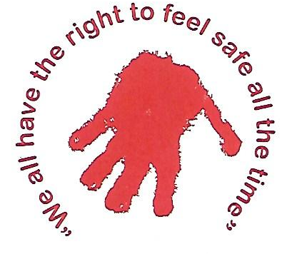

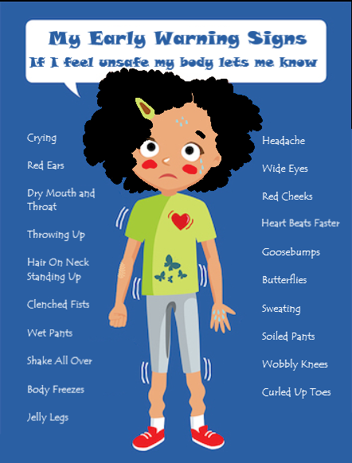

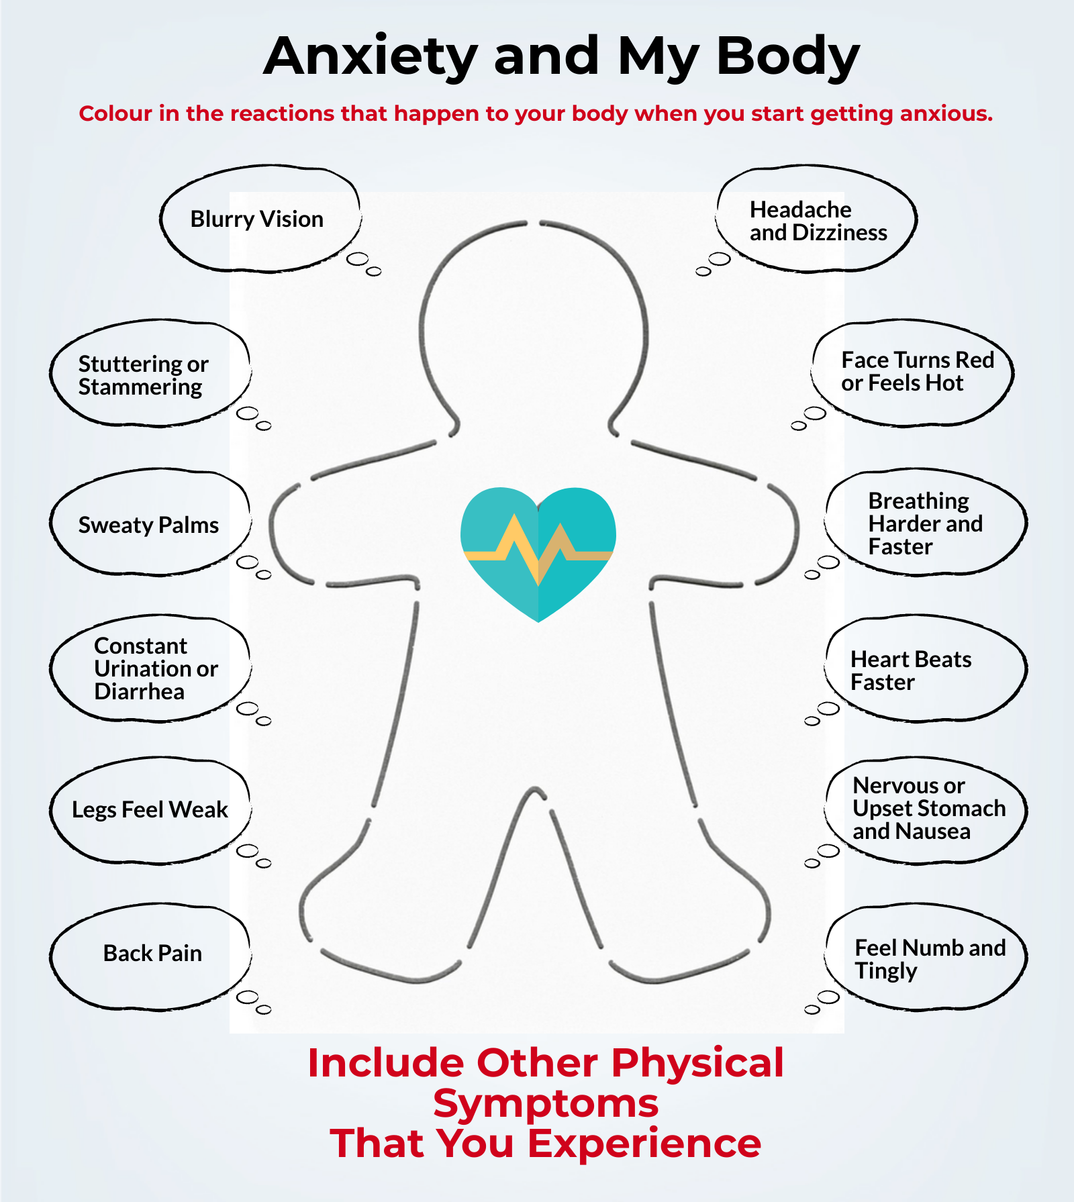

My Safety Network

These are five adults I trust and feel safe sharing my feelings with. I feel comfortable with these adults and can tell them what is on my mind and they will believe me. If I feel unsafe, anxious or scared I can talk to someone on my support network, I know they will help or support me. I will tell the person I choose how I am feeling and why I feel this way!

Instructions for your Helping Hand
- Put an adult’s name on each finger (5 adults)
- Put the name of your friend or something (teddy, diary) that you like to talk to on your palm.
- Put the names of support organisation or your emergency contacts (999) on your wrist.
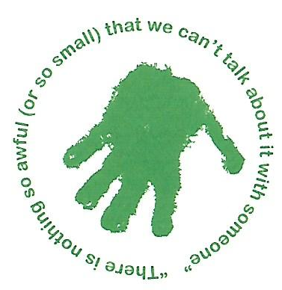
Remember: your support network can change depending on your circumstances.

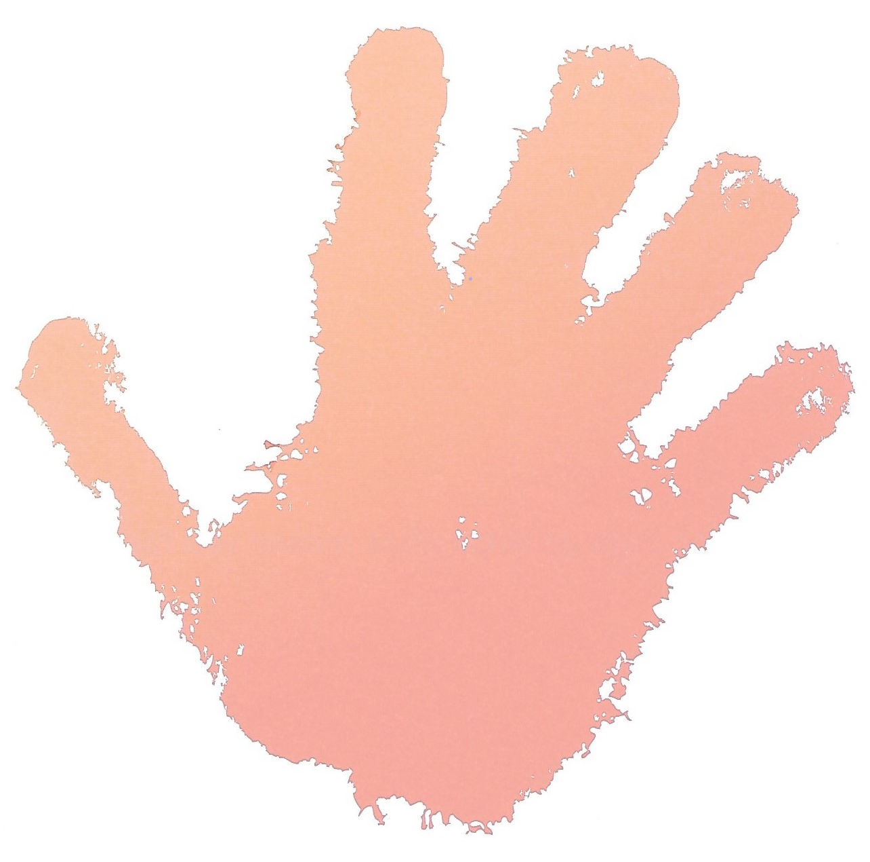
Remember!
It’s okay to ask for help. Your Helping Hand is there for you when you need it!

