This is how I feel today: (circle as many as you are feeling)

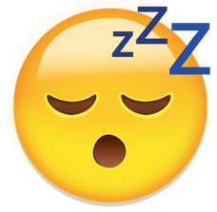



**Happy Sad Nervous Angry Tired Scared**





**Loved Sick Excited Safe Worried**

Draw or write about whatever is on your mind:

During this time, you may feel anxious or worried. It is ok to feel these feelings. What are some things or situations that make you feel a little anxious, anxious and very anxious?



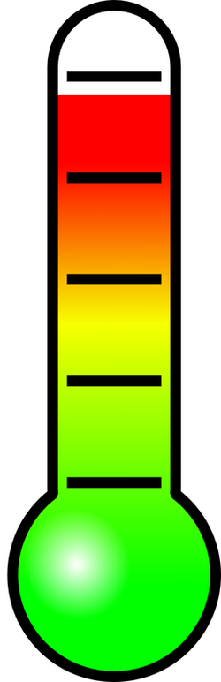

VERY ANXIOUS

Anxious

A little anxious

Calm

Colour in the reactions that happen to your body when you feel anxious

**ANXIETY AND MY BODY**

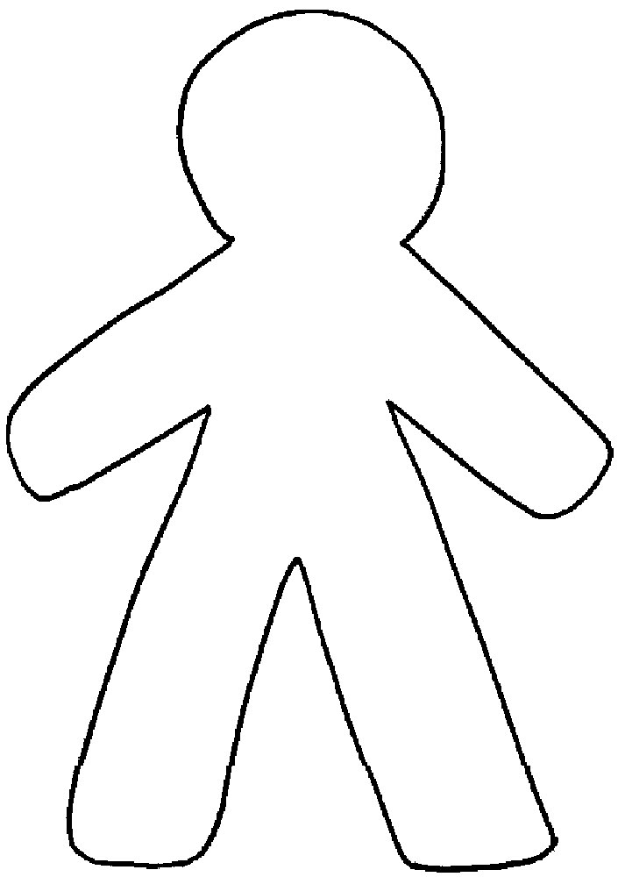

**DESIGN YOUR OWN AXIETY SUPERHERO**

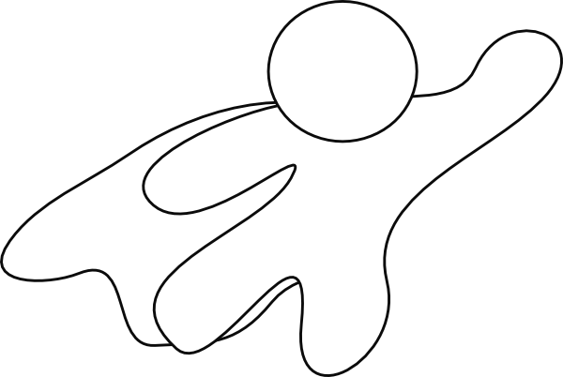

Superhero name:

**Superhero anxiety powers**